Assembly Language

Assembly language is a low-level programming language that provides a way to write instructions that a computer’s CPU can directly understand. It is closely related to machine language but uses mnemonics (symbolic codes) instead of binary numbers, making it easier for humans to read and write.
In assembly language, each instruction corresponds directly to a specific operation performed by the processor, such as moving data, performing arithmetic, or controlling program flow. Because of this, it gives programmers fine control over hardware, memory, and performance.
Assembly language programs are written using an Assembler like TASM, MASM, or EMU8086, which converts the assembly code into machine code (object code) that the CPU can execute.

Key Features
- Uses mnemonics (e.g., MOV, ADD, SUB) instead of binary.
- Works directly with registers and memory addresses.
- Allows fast and efficient execution.
- Provides hardware-level control.
Basic Structure of an Assembly Program
- Data Segment – Defines variables and messages.
- Code Segment – Contains the main program instructions.
- Stack Segment – Temporary storage for data during program execution.
- End Statement – Marks the end of the program.
Applications
- Embedded systems programming
- Device drivers and hardware control
- Performance-critical software
- Learning how computers execute instructions at the hardware level

Lab 01
INTRODUCTION AND NUMBER CONVERSION

Task 1: Decimal Conversions
Convert the following decimal number into binary , octal and hexadecimal

Question no 1 :
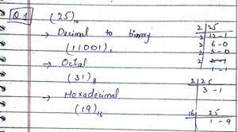
Question no 2 :
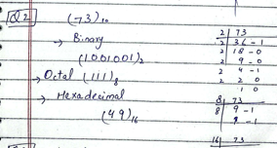

Question no 3 :
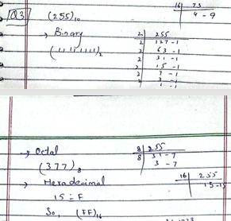
Question no 4 :
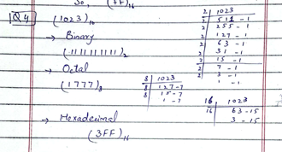

Task 2: Binary Conversions
Convert the following binary numbers into decimal and hexadecimal

Question no 1 :
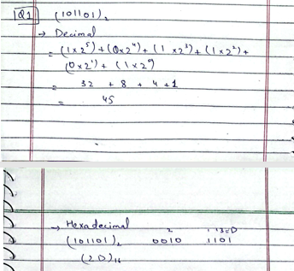
Question no 2 :
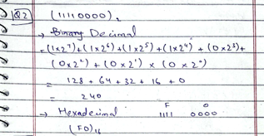
Question no 3 :
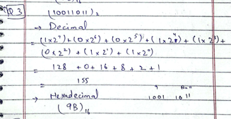
Question no 4 :
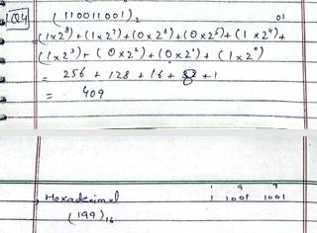
Task 3: Hexadecimal Conversions
Convert the following hexadecimal into binary and decimal
Question no 1:
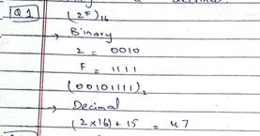
Question no 2:
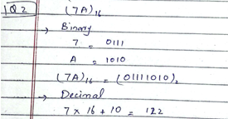
Question no 3:
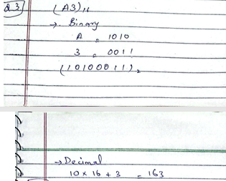
Question no 4:
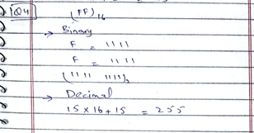

Lab 02
INSTALLATION OF EMU

Introduction
An emulator is a software program that allows your computer to imitate another system’s hardware or environment, so you can run and test programs made for that system.
In assembly language, an emulator provides a virtual CPU (such as the Intel 8086 processor) where students can write, assemble, debug, and execute their programs without needing actual hardware. It helps visualize how assembly instructions interact with registers, memory, and the processor.

EMU8086
EMU8086 is one of the most popular emulators used for learning assembly language. It simulates the Intel 8086 microprocessor, providing an easy interface for beginners.
It includes:
- Editor: to write assembly code
- Assembler: to convert code into machine language
- Debugger: to step through code and observe register/memory changes
- Virtual Machine: to execute the program

Advantages of Using EMU8086
- Easy to install and user-friendly interface
- Real-time display of registers and flags
- Allows step-by-step execution and debugging
- Helps students understand how CPU instructions work internally
- No need for physical hardware

Step 1: Click next to download
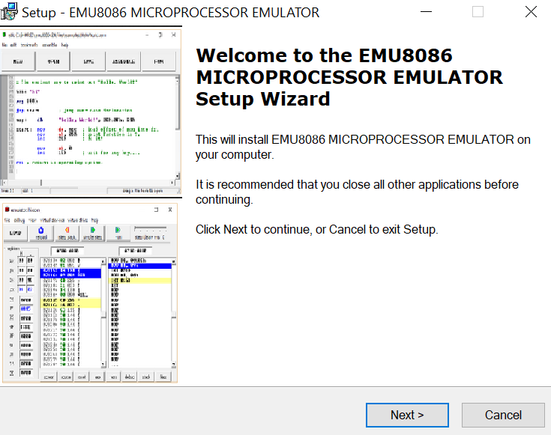
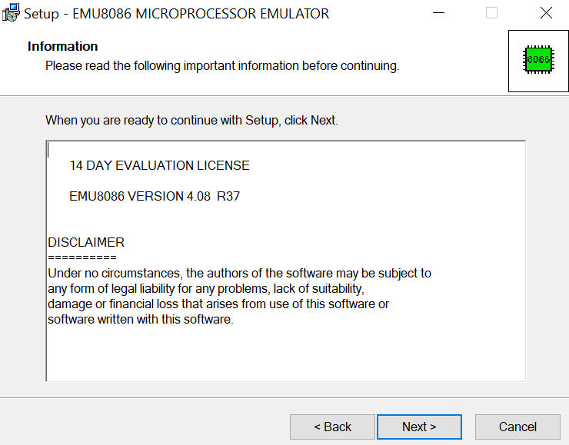

Step 2: Select location
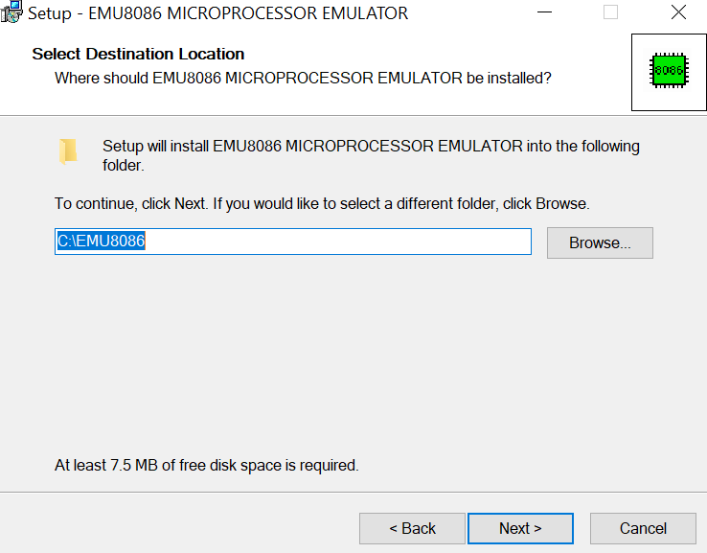
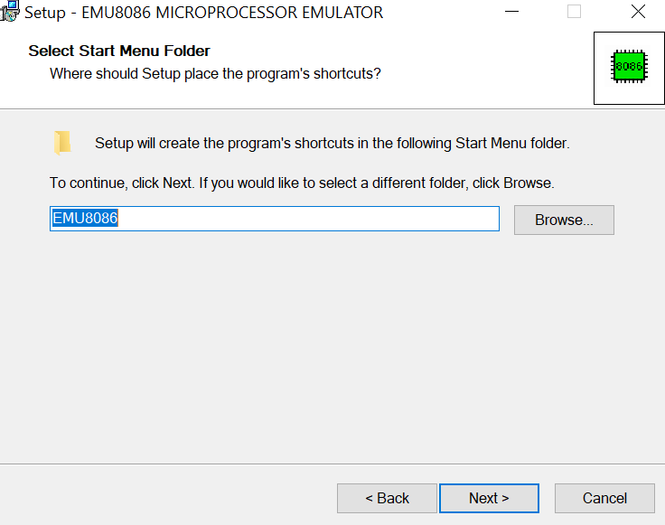

Step 3: Ready to install
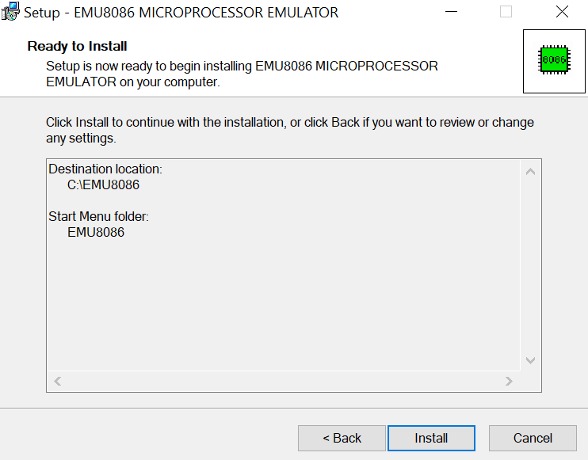

Step 4: Finish setting up
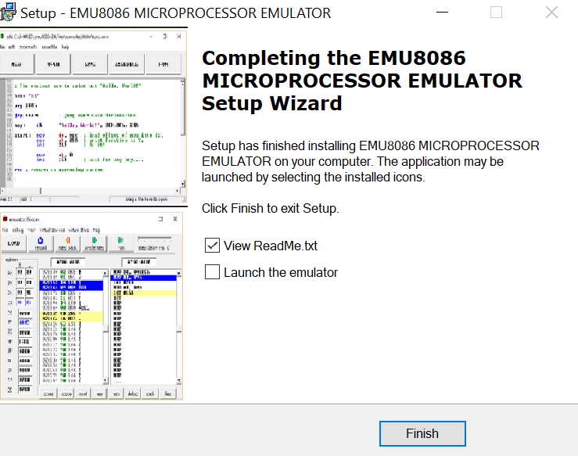
Step 5: Print ‘hello world’
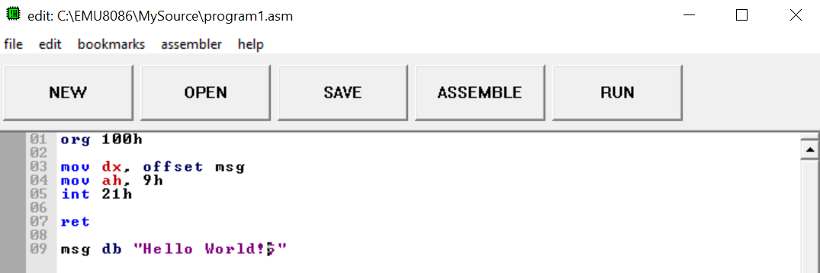
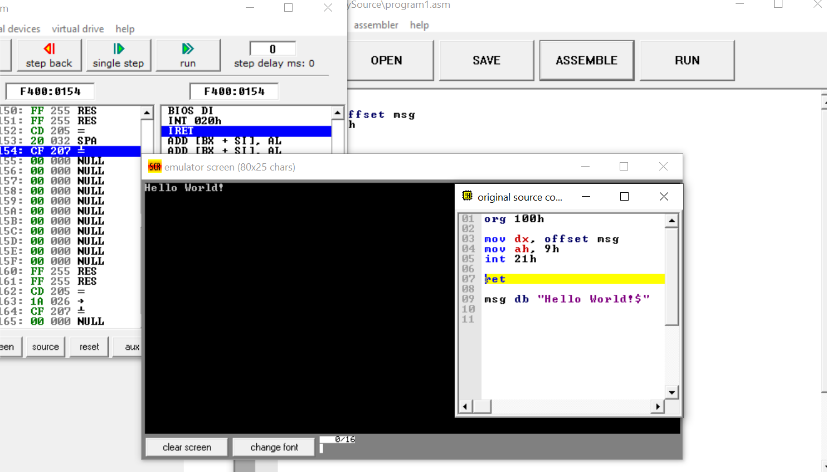
Step 6: Output
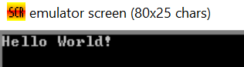
Lab 03
Basic Codes

Write a program to display your full name on the screen using INT 21h
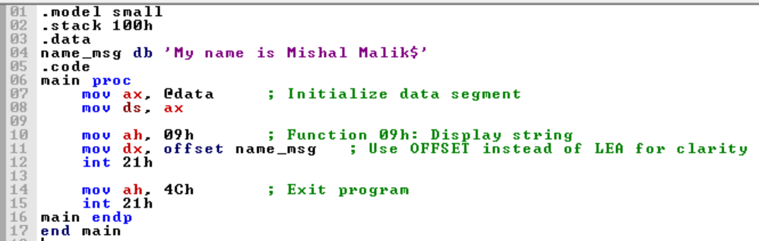
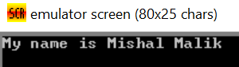
Compare two numbers stored in registers
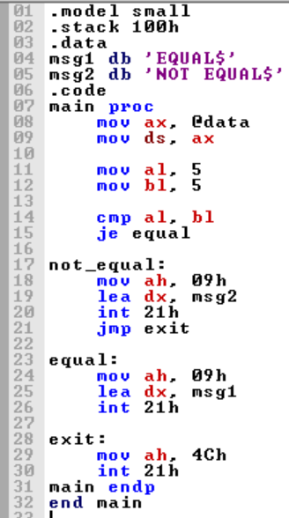
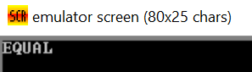
Write a program to print all uppercase alphabets A–Z using a loop
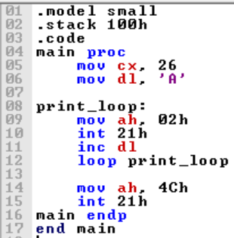
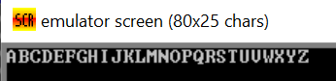
Write a program that prints the message "HELLO" five times using a loop
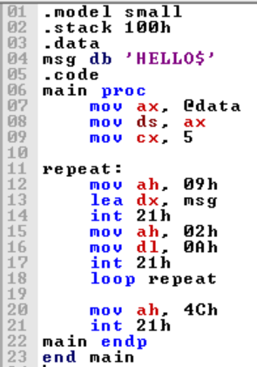
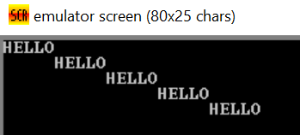

Write a program to display all digits from 0 to 9 in one line
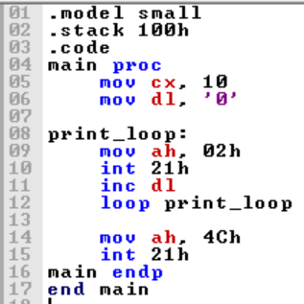

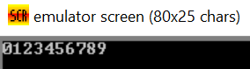
Push characters 'A', 'B', 'C' onto the stack, then pop them and display themback.
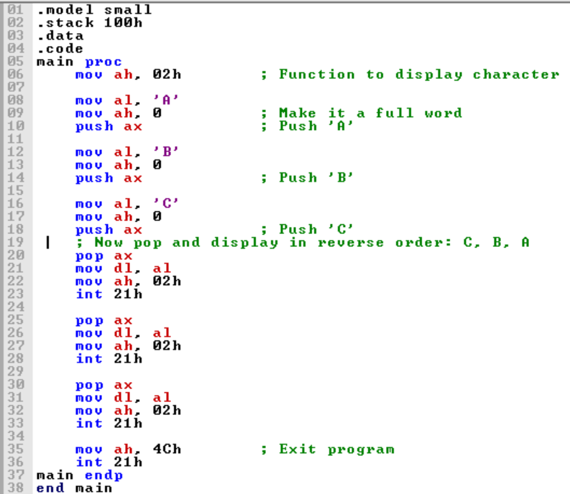
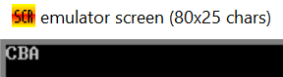
Write a program to print only even-position alphabets
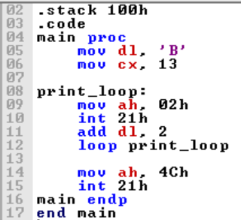
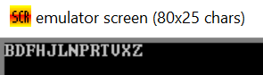

Write a program that checks a number in AX
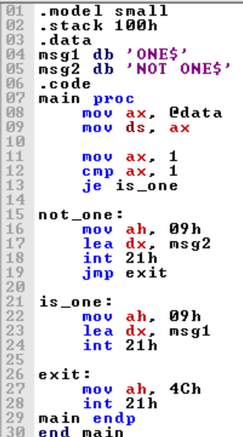

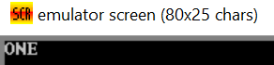
Store your roll number in a message and print it using INT 21h
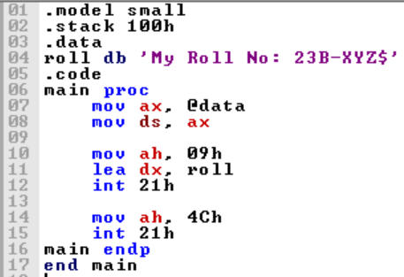
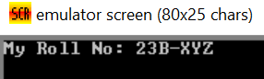
Write a program that prints * * * * * with a small pause (using a loop as delay counter)
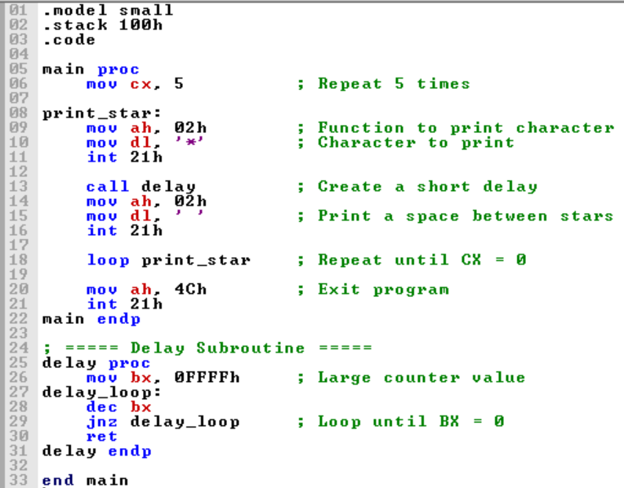

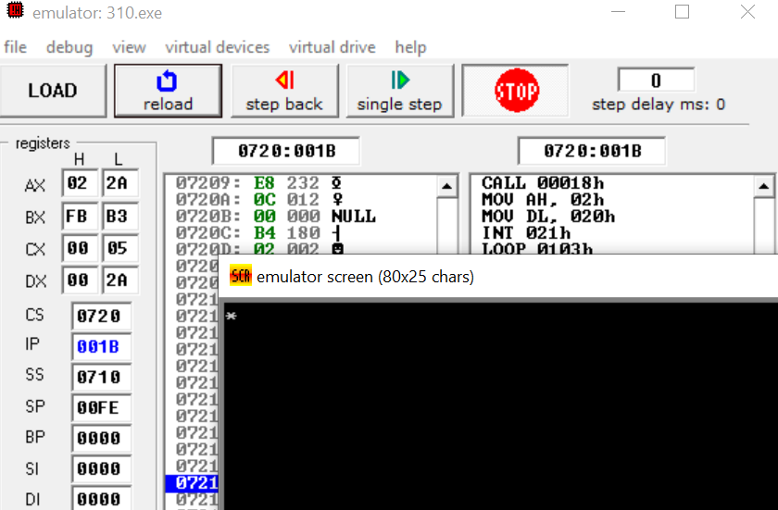

Lab 04
Arithmetic Instructions
Introduction:
The x86 architecture provides fundamental instructions for performing arithmeticoperations: ADD (addition), SUB (subtraction), MUL (multiplication), and DIV(division). These operations are essential for any computation and often utilize general-purposeregisters like AX, BX, CX, and DX for both operands and results. This lab focuseson16-bit

1. Addition (ADD)
Scenario 1: 1000h + 2000h = ?
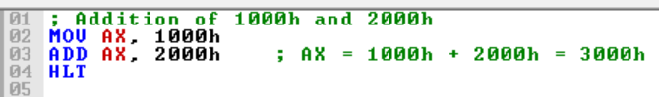
Predicted Result: AX = 3000h
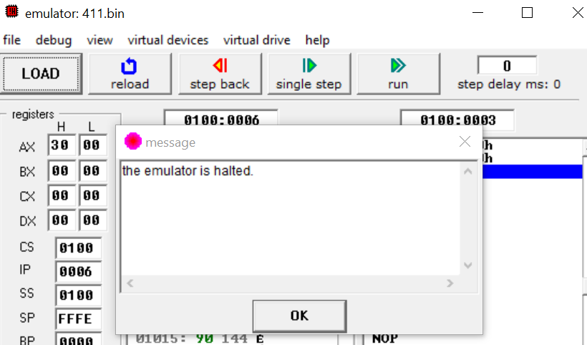
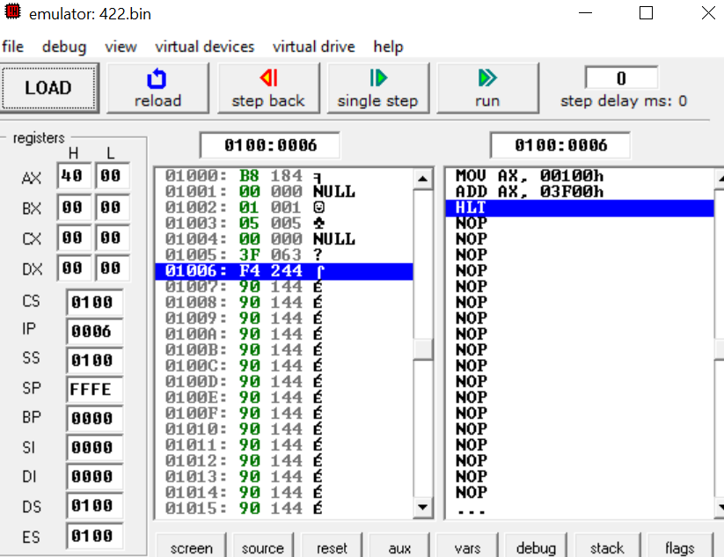

Scenario 2: 0100h + 3F00h = ?
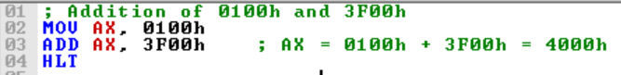
Predicted Result: AX = 4000h

2. Subtraction (SUB)
Scenario 1: 00A0h - 0050h = ?
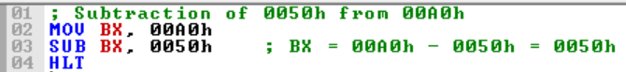
Predicted Result: BX = 0050h

Scenario 2: 2000h - 1F00h = ?
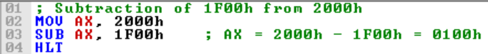
Predicted Result: AX = 0100h

Scenario 3: 0000h - 0001h = ?
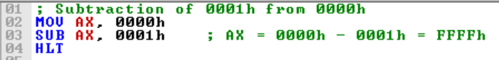
Predicted Result: AX = FFFFh (−1 in two’s complement)

3. Multiplication (MUL)
Scenario 1: 10h × 03h = ?
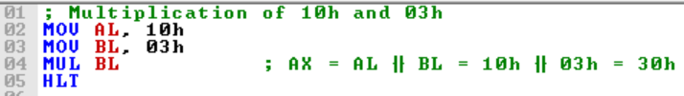
Predicted Result: DX = 0000h, AX = 0030h

Scenario 2: 64h × 04h = ?
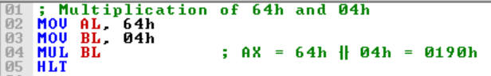
Predicted Result: DX = 0000h, AX = 0190h

4. Division (DIV)
Scenario 1: 20h ÷ 04h = ?
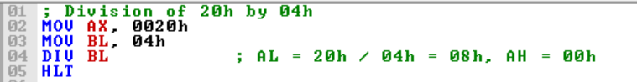
Predicted Result: AX = 08h (Quotient), DX = 00h (Remainder)

Scenario 2: 1Ah ÷ 05h = ?
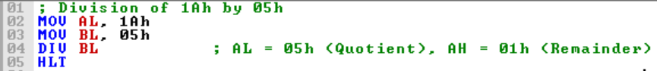
Predicted Result: AX = 05h (Quotient), DX = 01h (Remainder)

Scenario 3: 1000h ÷ 10h = ?
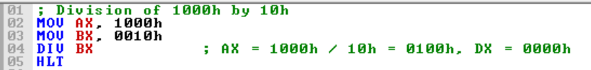
Predicted Result: AX = 0100h (Quotient), DX = 0000h (Remainder)

